1.
import java.net.*;
import java.io.*;

public class LocalIP
{
public static void main(String args[]) throws Exception
{

InetAddress ipadd=InetAddress.getLocalHost();
try{
System.out.println("IP address :"+ipadd);
}
catch(Exception e){
System.out.println(e);
}

}
}
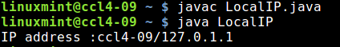

2.
import java.net.*;
import java.io.*;

public class AllIP
{
public static void main(String args[]) throws Exception
{

InetAddress ipadd[] =InetAddress.getAllByName("www.google.com");
try{
for(int i=0;i<ipadd.length;i++)
System.out.println("IP address :"+ipadd[i]);
}
catch(Exception e){
System.out.println("Error occurred");
}

}
}

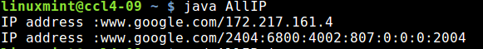

3.

import java.io.*;
import java.net.*;

class PingIP
{
public static void sendPingRequest(String ipAddress) throws UnknownHostException, IOException
{
InetAddress geek = InetAddress.getByName(ipAddress);
System.out.println("Sending Ping Request to " + ipAddress);
if (geek.isReachable(5000))
System.out.println("Host is reachable");
else
System.out.println("Destination Host Unreachable");
}
public static void main(String[] args)
throws UnknownHostException, IOException
{
String ipAddress = "127.0.0.1";
sendPingRequest(ipAddress);

}
}

